Teachers guide 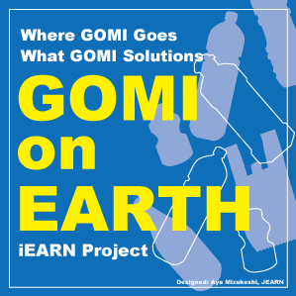 to lead students

**<Teachers guide>**

**Students work as an individual or a group, or the whole class, share what they find or create on iEARN GOMI forums, compare, stimulate, encourage each other for the final goals.**

**You can take Part I、Part II, and Part III anytime according to your class-time. The length of Part I ~Part III is free.**

**Please encourage your students not only postings their own to forums, but also visit other postings and interact each other !**

**Part I: You are GOMI Detectives**

**You can take all topics from 1~7, or take some topics depending on the class time.**

1. **What is GOMI for you? How do you define GOMI?**

**If you are asked what GOMI is, what do you answer. Post students’ definition on iEARN GOMI forum PART I: Topic1 “**What is GOMI for you?” (with name and country)

**E.g.: “GOMI is something I do not use anymore”.**

1. **What GOMI is around you? Please make a list of them.**

**Students make a list or illustrate them. Group discussion. Post them on PART I:Topic2**

**“**What GOMI is around you?”

**Look other postings and give their comments on them. Lead students to interactive online discussion.**

**E.g.: 12 GOMI pieces at my house:**

Fish head・Vegetable piece・Broken shoes・PET bottle・Coffee can・

Empty wine bottle・Plastic container/cover・Old short・Ceramic cup・

Unusable metal kettle・core of toilet paper・Cardboard

1. **Where do they go after leaving your house/school ?**

**Who takes your GOMI away? Who/ What/How/How often**

**Each city has a different system. Research their city system and post it on PART I:Topic 3**

**“**[Where do they go after leaving your house/school ?](https://iearn.org/cc/space-2/group-478/topic-40284)”

|  |  |  |  |  |  |  |
| --- | --- | --- | --- | --- | --- | --- |
| **In case of Yokohama city (sorry it is in Japanese)** | | | | | | |
| 色同じ色の品目は同じ曜日に収集されます。**各項目の詳細は画像をクリックしてください。** | | | | | | |
| [燃やすごみ](http://www.city.yokohama.lg.jp/shigen/sub-shimin/dashikata/das1.html) | [燃えないごみ](http://www.city.yokohama.lg.jp/shigen/sub-shimin/dashikata/das11.html) | [乾電池](http://www.city.yokohama.lg.jp/shigen/sub-shimin/dashikata/das4.html)[スプレー缶](http://www.city.yokohama.lg.jp/shigen/sub-shimin/dashikata/das10.html) |  |  | [缶・びん・ペットボトル](http://www.city.yokohama.lg.jp/shigen/sub-shimin/dashikata/das2.html)[小さな金属類](http://www.city.yokohama.lg.jp/shigen/sub-shimin/dashikata/das8.html) | |
| [プラスチック製容器包装](http://www.city.yokohama.lg.jp/shigen/sub-shimin/dashikata/das12.html) | | [古布](http://www.city.yokohama.lg.jp/shigen/sub-shimin/dashikata/das13.html) | [古紙](http://www.city.yokohama.lg.jp/shigen/sub-shimin/dashikata/das14.html) | | | |
| [粗大ごみ](http://www.city.yokohama.lg.jp/shigen/sub-shimin/dashikata/das3.html) | | |  | | --- | | ●**粗大ごみ受付センター** 　（月～土曜日、8時30分～17時） ●**インターネット受付**[https://www.sodai.city.yokohama.lg.jp](https://www.sodai.city.yokohama.lg.jp/) | | | | | [動物の死体](http://www.city.yokohama.lg.jp/shigen/sub-shimin/dashikata/das5.html) |

1. **How is GOMI on public sites ?**

**Students go out to the parks for example, research GOMI around, take photos if they have trash boxes. Post them on PART I:Topic4 “**[How is GOMI on public sites ?”](https://iearn.org/cc/space-2/group-478/topic-40285)**.**

**Enjoy public GOMI boxes/designs in other countries.**

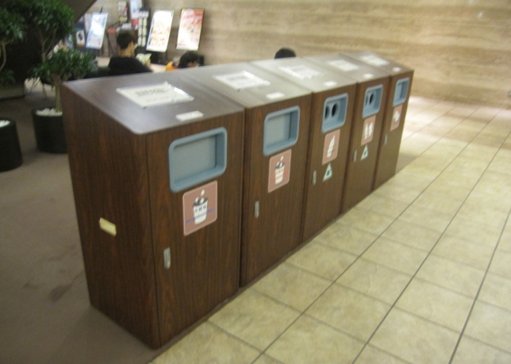 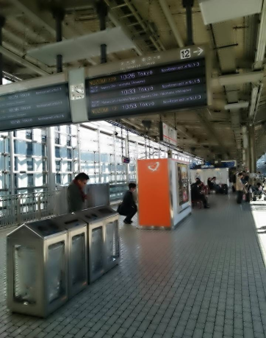

1. **How does GOMI contribute us?**

**Reuse? Recycle? Reform? Heat? Electricity? More? Forum PART I:Topic5**

1. **What is their final stage? Where they are/How they are? Forum PART I Topic6**
2. **Make “Where GOMI goes Map”, in short “GOMI Map”**

**You can skip #5 and 6, and jump to #7. But students will fully enjoy GOMI Map making when they go through #5 and 6.**

**The design of GOMI Map is free. Share their GOMI Maps on PART I:Topic7.**[“GOMI Map”](https://iearn.org/cc/space-2/group-478/topic-40288).or New Discussions.

**Again encourage students “online interactive conversation”.**

**Part II: World GOMI Reality**

1. **Learn “World GOMI reality”**

**Marine Litter・５ GOMI Belts in oceans**

**GOMI Mountains・Landfill**

**Micro Plastic in the sea**

**Resources to share with students**

“GreatPacificGarbagePatch”

<http://nationalgeographic.org/encyclopedia/great-pacific-garbage-patch/>

Turning the Tides on Plastic Pollution <http://innovatedevelopment.org/2016/02/01/plastic>

Abundance of microplastics in the world's deep seas

<https://www.sciencedaily.com/releases/2014/12/141216212253.htm>

The Menace of Marine Litter [**http://www.ecomena.org/marine-litter/**](http://www.ecomena.org/marine-litter/)

**Photo site:**

[**http://www.bing.com/images/search?q=%e3%82%b4%e3%83%9f%e3%81%ae%e5%b1%b1+%e5%86%99%e7%9c%9f&id=D8EF0343BE6D8D3FE53C941BFD4D152EDF98BF80&FORM=IQFRBA**](http://www.bing.com/images/search?q=%e3%82%b4%e3%83%9f%e3%81%ae%e5%b1%b1+%e5%86%99%e7%9c%9f&id=D8EF0343BE6D8D3FE53C941BFD4D152EDF98BF80&FORM=IQFRBA)

**How Landfills Work**　　<http://science.howstuffworks.com/environmental/green-science/landfill.htm>

**Plastic Pollution Accumulation Zones by JBPA (Japan Bioplastic Association )**



**There are many more resources on internet. Please find them and share with us!**

**Listen to student comments.**

**Post them on GOMI forums PART II:Topic1”**[Learn “World GOMI Reality”](https://iearn.org/cc/space-2/group-478/topic-40289).

2. Watch “Plastic into Oil “

[**http://www.youtube.com/embed/qGGabrorRS8?rel=0**](http://www.youtube.com/embed/qGGabrorRS8?rel=0)

<https://www.youtube.com/watch?v=R-Lg_kvLaAM>

Message of Mr.Akinori Ito, the presenter of these film:

GOMI( meaning waste in Japanese): Wherever you may live, the GOMI will appear with the life activity of anyone such as eating, drinking and etc. You too produce GOMI to maintain your life.

Here is something we must reconsider about!

Things can be classified into 2 categories. Durable things to be used continuously or things used only once and become GOMI immediately after use. Among the wasted things, there are things to be recycled properly sorted out. You should have seen such recycled products.

My company produces such machines and system which recycle waste plastic converting into petroleum.

However, waste plastic is not always recyclable. The following three kinds are available for recycling: PP(polypropylene)・PE(polyethylene)・PS(polystyrene)

Roughly telling, 1kg of these plastic can produce 1ℓ of oil.

Careful watch in your daily life will tell you that there are those 3 types plastic around you.

How wonderful it would be, if the wasted plastic material can be limited only in these 3 kinds material and PET Bottle  which is already recycled changing form.

Why not starting now!!

Picking up PP・PE・PS sorting out from waste to convert into oil.

Store them for a month, and sum the total number!

Through the global network of the iEARN, tell the world how much volume of those plastics can be stored in a month, that will make the world realize the importance of the GOMI resource for getting oil.

**Please post student comments on this topic-2.**

**Part III: You are GOMI Activists**

**Your actions to care GOMI and your GOMI solutions:**

1. **How do you care GOMI around you in fun useful ways rather than dumping more GOMI on EARTH?**
2. Present your actions /solutions by any medias you like such as:

Videos /Photos/ Paintings /GOMI Songs/ GOMI Dancing/ picture books/GOMI characters/

**This is the final class time work. Hope students enjoy creating their media.**

**Post all of their media on New Discussions.**

**<To teachers>**

**Thank you for your collaborations. Hope you enjoy yourself to look at GOMI around you**

|  |  |  |  |
| --- | --- | --- | --- |
| **and work with your students to get into GOMI on EARTH project.**  **Any supportive practical ideas are welcome!** |  |  |  |