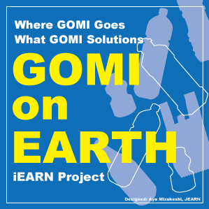

TITLE GOMI on Earth

Summary
I am GOMI. People say it is Garbage/Trash in English. This project is about a long journey of GOMI on EARTH.

Description
You are “GOMI detectives” at Part I. You follow its long journey to final destination on EARTH. You face "World GOMI Reality“ at Part II. And you are "GOMI activists” at Part III, where you care GOMI and reach your creative GOMI solutions. You can take Part I ~ Part III freely according to your class time.
Reference: “Teachers Guide” in "About/Resources" and “Teachers room” for a description of activities.

Facilitators
- Lakshmi Chintaluri, India
- Kathy Bosiak, United States
- Yoko Takagi, Japan

Languages English

Student Age Levels
5-11 (Primary), 12-14 (Middle), 15-18 (Secondary)

Dates Sep 01 2017 - Jul 31 2018

Possible classroom activities
You can take Part I ~ Part III according to your class time
Part I: You are GOMI Detectives
What is GOMI for you? How do you define GOMI?
What GOMI is around you? Please make a list of them.
Where do they go after leaving your house/school ?
Who takes your GOMI away?
Who/What/How/How often?
How is GOMI on public sites?
How does GOMI contribute us?
Reuse? Recycle? Reform? Heat? Electricity? More?
What is their final stage? Where they are/How they are?
Make “Where GOMI goes Map”, in short “GOMI Map”
Part II: World GOMI Reality
Learn and face “World GOMI reality”
Marine Litter・５ GOMI Belts in oceans
GOMI Mountains・Landfill
Micro Plastic in the sea
Watch videos "Plastic into Oil"
Part III: You are GOMI Activists
You are GOMI Activists. Your actions to care GOMI and GOMI solutions, share them with your favorite media.

Expected outcomes
GOMI pieces・GOMI Map・Creative media about "how you care GOMI" and "what your GOMI solutions are."

Group contributions to others and/or the planet:
To develop such culture about “GOMI SORTING” before leaving your hands.
To keep our mother land and ocean as healthy EARTH
SDG 11 Make cities and human settlement inclusive, safe, resilient and sustainable
SDG 14th Conserve and sustainably use the oceans, seas and marine resources for sustainable development

Curriculum area
Environment, Social science, Science, Language arts

